Ideation Phase
Brainstorm & Idea Prioritization

Date | 14 February 2026
Team ID | LTVIP2026TMIDS24417
Project Name | HematoVision: Advanced Blood Cell Classification Using Transfer Learning
Marks | 4 Marks

Step-1: Team Gathering, Collaboration and Select the Problem Statement
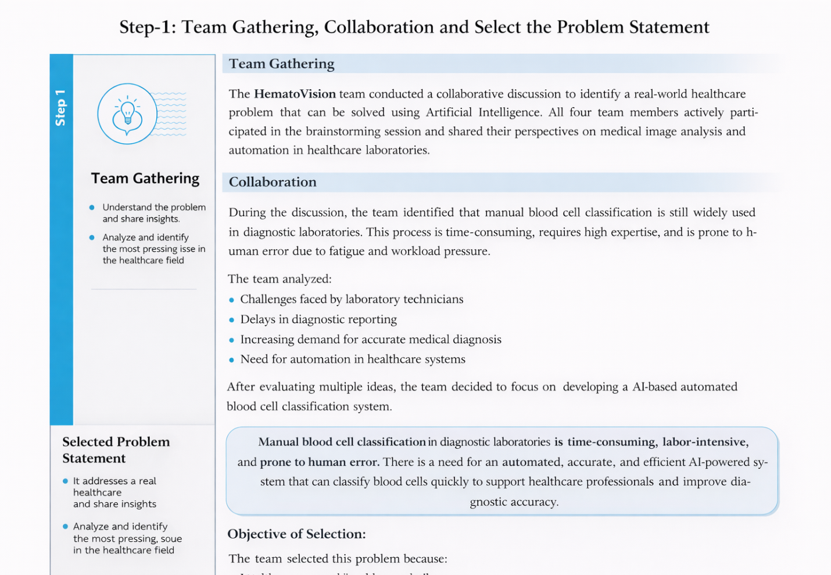

Step-2: Brainstorm, Idea Listing and Grouping
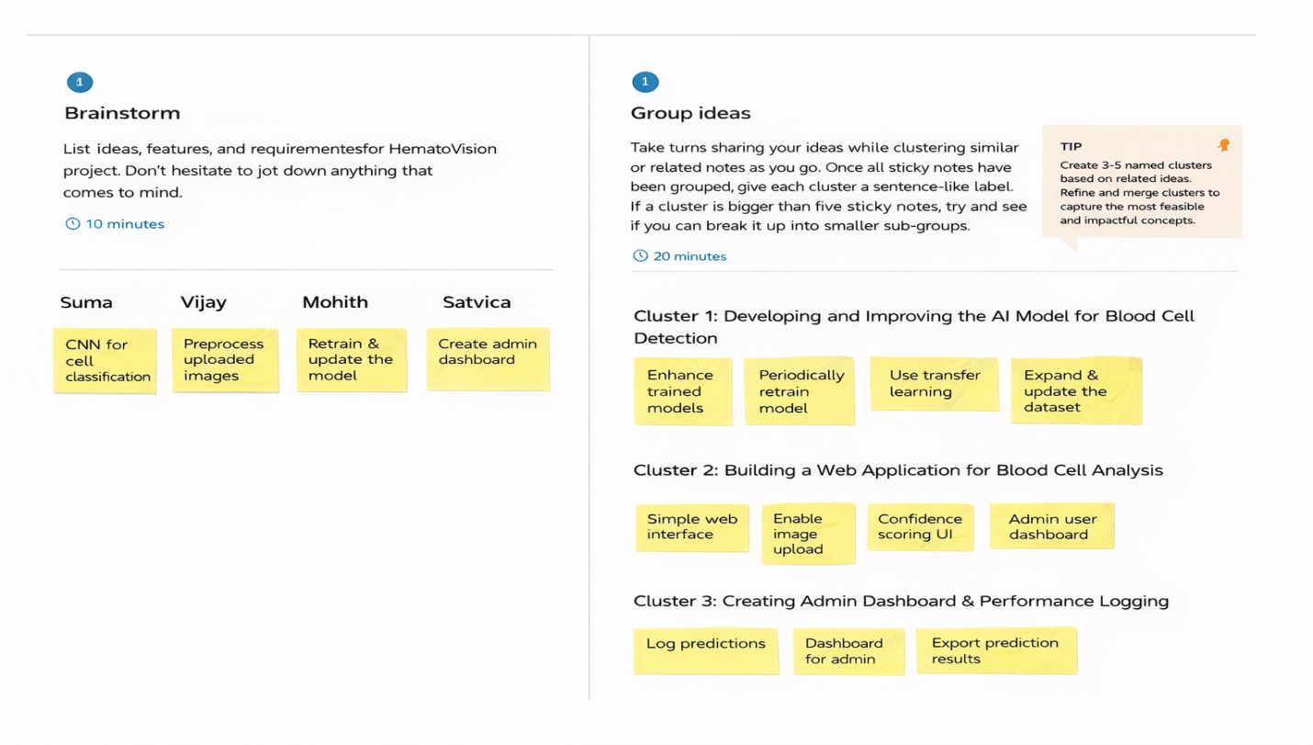

Step-3: Idea Prioritization
